HIGH-LEVEL DESIGN DOCUMENT

GOOGLE PAY

Date:28-02-2024

JAGADEESHWARI S V

Top of Form

**Table of Contents**

1. **Introduction**
   * 1.1 Overview
   * 1.2 Purpose
2. **Architecture Overview**
   * 2.1 Client Side
   * 2.2 Server Side
3. **Key Features**
   * 3.1 Payment Methods
   * 3.2 Transaction Security
   * 3.3 Peer-to-Peer Payments
   * 3.4 Bill Payments
   * 3.5 Loyalty Programs Integration
   * 3.6 In-Store Payments
4. **Technology Stack**
5. **Conclusion**

**1. Introduction**

**1.1 Overview**

Google Pay is a digital wallet platform developed by Google that enables users to make payments using their smartphones, tablets, or other devices. It allows users to store payment information securely, make purchases online and in stores, send money to friends and family, and manage loyalty cards and rewards.

**1.2 Purpose**

The purpose of this document is to provide a high-level overview of the design of the Google Pay platform, including its architecture, key features, and functionality.

**2. Architecture Overview**

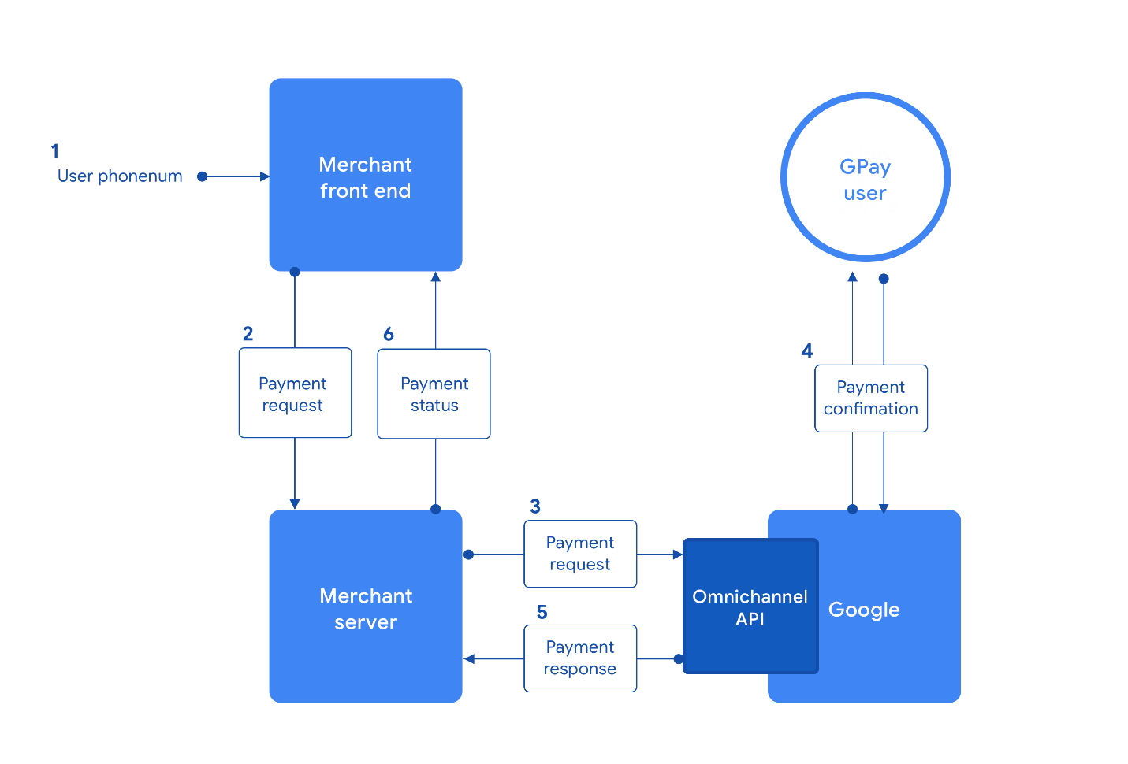

**2.1 Client Side**

* **Mobile App Interface**: Provides a user-friendly interface for users to manage payment methods, make transactions, and access other features.
* **Security Layer**: Implements security measures such as biometric authentication (e.g., fingerprint or face recognition) to ensure the security of transactions.
* **NFC Technology**: Enables contactless payments using Near Field Communication (NFC) technology for in-store transactions.
* **Integration with Device Wallets**: Integrates with device-specific wallets (e.g., Apple Wallet on iOS devices) to streamline the payment process.

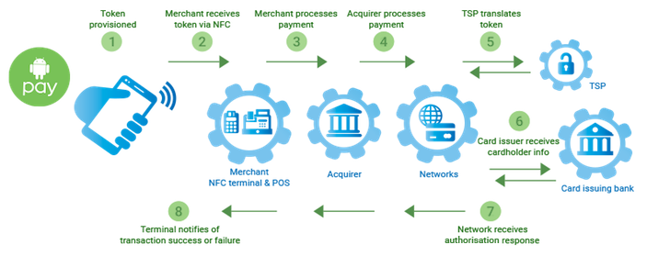

**2.2 Server Side**

* **Payment Gateway Integration**: Interfaces with payment gateways to process transactions securely and efficiently.
* **Identity and Authentication Services**: Manages user authentication and authorization processes to ensure secure access to payment information.
* **Tokenization Service**: Utilizes tokenization to replace sensitive payment card information with unique tokens, reducing the risk of data theft.
* **Fraud Detection and Prevention**: Implements algorithms and measures to detect and prevent fraudulent transactions in real-time.
* **Data Analytics and Reporting**: Collects and analyzes transaction data to provide insights into user behavior, trends, and performance.

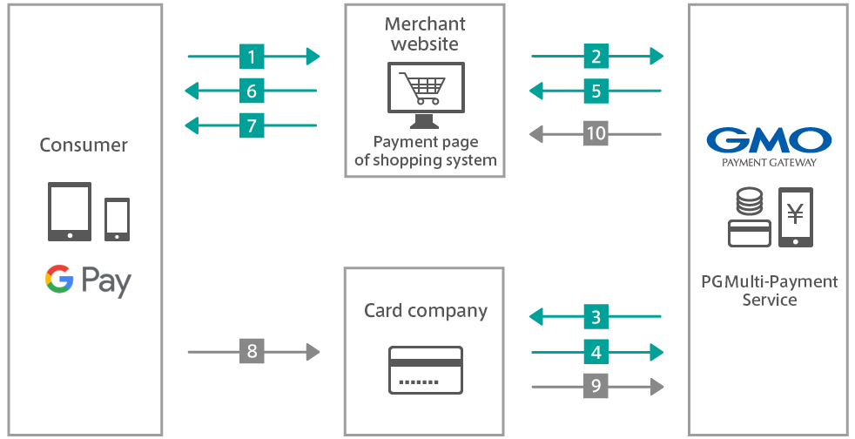

**3. Key Features**

**3.1 Payment Methods**

* **Credit/Debit Cards**: Allows users to add and store credit or debit card information for making purchases.
* **Bank Accounts**: Supports linking bank accounts for direct transfers and payments.
* **Digital Wallets**: Integrates with digital wallets such as PayPal or Venmo for added convenience.
* **UPI (Unified Payments Interface)**: Facilitates peer-to-peer payments and transactions with Indian banks.

**3.2 Transaction Security**

* **Tokenization**: Replaces sensitive payment card information with tokens to enhance security.
* **Multi-factor Authentication**: Implements multiple layers of authentication, including biometric authentication, PIN codes, or one-time passwords (OTP).
* **Encryption**: Secures data transmission and storage using encryption protocols to prevent unauthorized access.

**3.3 Peer-to-Peer Payments**

* **Send Money**: Enables users to send money to friends, family, or contacts using their phone numbers or email addresses.
* **Request Money**: Allows users to request payments from others, making it convenient for splitting bills or sharing expenses.

**3.4 Bill Payments**

* **Utility Bills**: Facilitates the payment of utility bills such as electricity, water, gas, and internet bills.
* **Mobile Recharges**: Allows users to recharge prepaid mobile phone accounts directly from the app.

**3.5 Loyalty Programs Integration**

* **Loyalty Cards**: Enables users to store and manage loyalty cards and rewards programs within the app.
* **Rewards Tracking**: Tracks and displays loyalty points, rewards, and offers from participating merchants.

**3.6 In-Store Payments**

* **Contactless Payments**: Supports contactless payments using NFC technology at compatible point-of-sale (POS) terminals.
* **QR Code Payments**: Allows users to scan QR codes at checkout to make payments securely and conveniently.

**4. Technology Stack**

* **Client Side**:
  + Android: Java/Kotlin, Android SDK
  + iOS: Swift, UIKit
* **Server Side**:
  + Backend: NodeJS
  + Database: MongoDB, MySQL
* **Payment Processing**:
  + Integration with payment gateways such as Stripe, PayPal, or Braintree
* **Security**:
  + Encryption protocols (SSL/TLS), tokenization services
* **Infrastructure**:
  + Cloud services such as AWS (Amazon Web Services), Google Cloud Platform, or Microsoft Azure

**5. Conclusion**

Google Pay provides a secure, convenient, and versatile platform for users to make payments, send money, and manage their finances. With its robust architecture, advanced security features, and seamless integration with various payment methods and services, Google Pay aims to enhance the digital payment experience for users worldwide.

**THANK YOU**

Top of Form